Software Design Approaches - Component-Based

📖 Definition
# Source: AI Source: Provided by: [Data Path: Persons Table -> ID Column: 1, Name_En Column: Motasem Essam] -> From: [ChatGPT] on [1/23/2026]
Component-Based Design (CBD) is a software design approach where systems are built by assembling independent, reusable components. Each component provides a specific functionality and interacts with other components through well-defined interfaces.
👉 In simple terms:
“Build software by combining reusable building blocks (components).”

⚙️ How It Works
# Source: AI Source: Provided by: [Data Path: Persons Table -> ID Column: 1, Name_En Column: Motasem Essam] -> From: [ChatGPT] on [1/23/2026]
- Identify functional components needed for the system
- Develop components with independent functionality
- Define clear interfaces for communication between components
- Assemble components to form a complete system
- Reuse components in other projects or systems

🧩 Key Characteristics
# Source: AI Source: Provided by: [Data Path: Persons Table -> ID Column: 1, Name_En Column: Motasem Essam] -> From: [ChatGPT] on [1/23/2026]
- Reusability → Components can be used across multiple systems
- Encapsulation → Internal details of a component are hidden
- Independent deployment → Components can be updated without affecting others
- Interface-driven design → Communication via defined contracts
- Promotes scalable and maintainable systems

✅ Advantages
# Source: AI Source: Provided by: [Data Path: Persons Table -> ID Column: 1, Name_En Column: Motasem Essam] -> From: [ChatGPT] on [1/23/2026]
- Reusability reduces development time
- Easier maintenance: Change one component without impacting others
- Parallel development: Multiple teams can work on different components
- Scalable: System can be extended by adding new components
- Consistency: Standardized components improve quality

⚠️ Disadvantages
# Source: AI Source: Provided by: [Data Path: Persons Table -> ID Column: 1, Name_En Column: Motasem Essam] -> From: [ChatGPT] on [1/23/2026]
- Integration complexity: Combining components may require significant effort
- Dependency management: Components must work together correctly
- Initial design effort: Requires careful planning of component interfaces
- Performance overhead: Component abstraction may introduce slight latency

🎯 Use Cases
# Source: AI Source: Provided by: [Data Path: Persons Table -> ID Column: 1, Name_En Column: Motasem Essam] -> From: [ChatGPT] on [1/23/2026]
- Enterprise systems with modular functionality
- Microservices architecture
- Large-scale web applications
- Reusable software libraries and APIs
- GUI frameworks (e.g., buttons, panels, widgets)

🛠️ Simple Example
# Source: AI Source: Provided by: [Data Path: Persons Table -> ID Column: 1, Name_En Column: Motasem Essam] -> From: [ChatGPT] on [1/23/2026]
Problem: Build an Online Shopping System
Components:
- User Management Component → Handles login, registration
- Product Catalog Component → Manages product information
- Shopping Cart Component → Handles item selection and totals
- Payment Component → Processes payments securely
- Order Management Component → Tracks order history
👉 Each component can be developed, tested, and updated independently, then integrated into the full system.

🔄 CBD vs Other Approaches (Quick Insight)
# Source: AI Source: Provided by: [Data Path: Persons Table -> ID Column: 1, Name_En Column: Motasem Essam] -> From: [ChatGPT] on [1/23/2026]
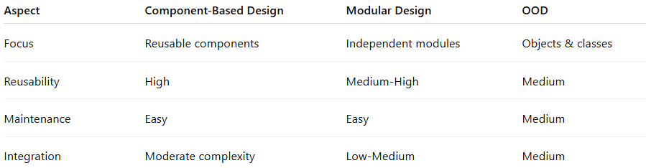
Aspect | Component-Based Design | Modular Design | OOD
Focus | Reusable components | Independent modules | Objects & classes
Reusability | High | Medium-High | Medium
Maintenance | Easy | Easy | Medium
Integration | Moderate complexity | Low-Medium | Medium

📌 Summary
# Source: AI Source: Provided by: [Data Path: Persons Table -> ID Column: 1, Name_En Column: Motasem Essam] -> From: [ChatGPT] on [1/23/2026]
Component-Based Design (CBD) focuses on building software from independent, reusable components that communicate via well-defined interfaces. It is ideal for large, complex systems that require scalability, maintainability, and parallel development. While it improves reusability and reduces development time, careful integration and interface design are essential.

